Quantitative Module B

Linear Programming

**Background**

Some educators might argue that linear programming is among the five most useful tools that can be learned in a business school. It can be used to solve very large problems with thousands of variables and constraints. Smaller problems can be solved with Excel, which is available on virtually all desktop computers with Microsoft Office 2007. Good linear programming formulations represent as much of an art as a science. Writing linear programs is a bit like going back to algebra class in junior high school and turning word problems into equations. Linear programming users improve their abilities via exposure to examples and practice. This module provides students with a nice introduction to the subject and a feel for what linear programs can do.

**Class Discussion Ideas**

1. The airlines must manage some of the most complicated scheduling problems in industry, due both to the complexity of each individual problem as well as the interconnectivity among the problems (for example, matching plane schedules with pilot schedules). A good way to begin the treatment of linear programming can be to introduce an airline refueling problem, i.e., determining how much fuel to take on at each stop when prices differ at each airport. What factors should the airline consider when making that decision? Discussion can then expand to crew scheduling, plane scheduling, flight schedules, etc., and the need for linear programming to approach such decisions.

**Active Classroom Learning Exercises**

1. Instructors can add a little twist to the production-mix example B2 from the text to see if students can begin to think logically about how to tackle more complicated scenarios with linear programming. In addition to the resource requirements for each product provided in the example, suppose that Product TR29 requires two units of Product BR788 as components, and Product XJ201 also requires one unit of Product TR29 as a component. Any units of BR788 or TR29 that are used as components in other products cannot be sold to customers. Change the label of “Minimum Production Level” to “Minimum Sales Level” (to distinguish products that are sold from products that are used as components), and double the capacities of each department (so that the new formulation will still be feasible).

The formulation is not completely obvious to students new to linear programming. Divide the class into small groups, and ask each group to try to re-formulate the model. Some will try to introduce new decision variables that distinguish products that are sold from products that are used as components—but that is not necessary. The only adjustment that is needed is to increase the resource usage coefficients for TR29 and XJ201. For example, the new drilling requirement for TR29 would be 2 + 2(3) = 8 hours. Then the new drilling requirement for XJ201 would be 3 + 1(8) = 11 hours. Similarly, TR 29 would have new coefficients of 3.5, 5, and 1.5 hours for wiring, assembly, and inspection, respectively; while XJ201 would have new coefficients of 4, 7, and 2 hours for wiring, assembly, and inspection, respectively.

The solution for the number of units sold is: XJ201 = 150, XM897 = 250, TR29 = 200, and BR788 = 400. In addition, the number of units produced as components can be computed as follows: TR29 = 150(1) = 150 units; BR788 = 200(2) + 150(2) =700 units.

2. See: *Lego Of My Simplex*. Pendegraft, Norman. 1997. OR/MS Today. Vol. 24, No. 1.

**Presentation Slides**

INTRODUCTION (B-1 through B-7)

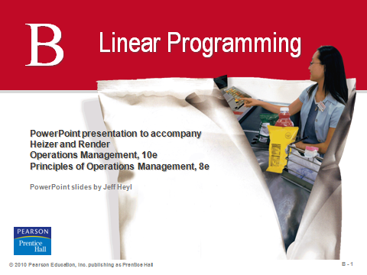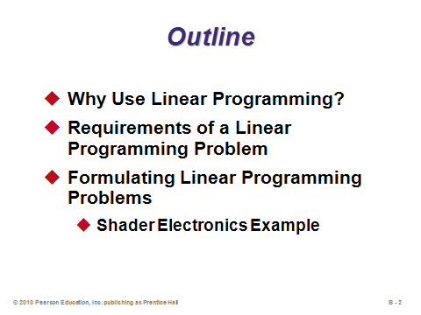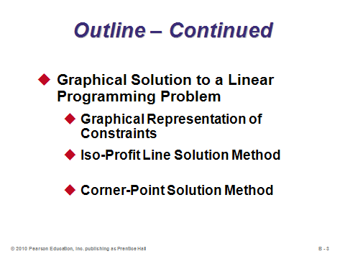

**B-1 B-2 B-3**

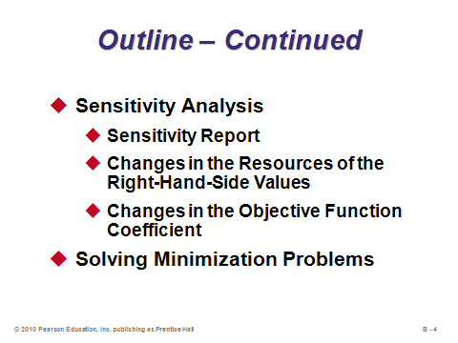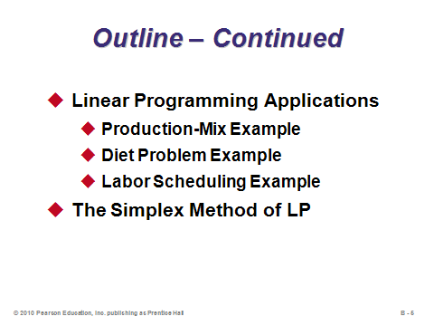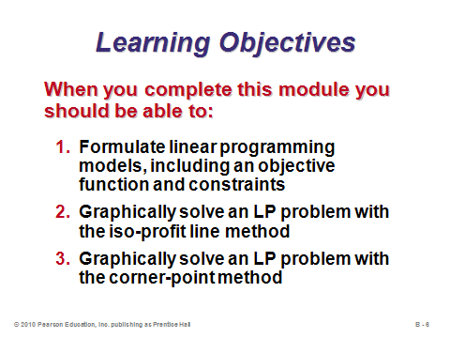

**B-4 B-5 B-6**

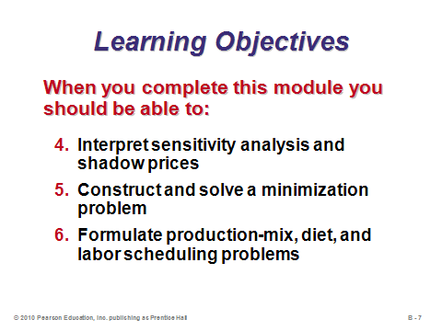

**B-7**

WHY USE LINEAR PROGRAMMING? (B-8 through B-11)

Slides 8-11: Linear programming is a very powerful tool that can be used to solve a tremendous variety of problems that cross all functional areas of an organization. Certain linear programming problems can be solved using Excel, which helps to make the tool more accessible to managers from all departments. Slides 9-11 identify several possible applications.

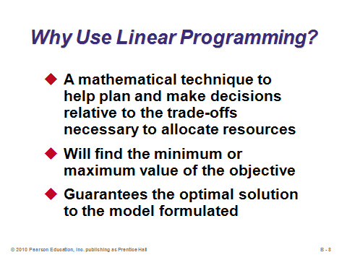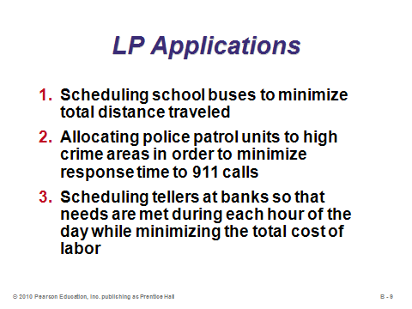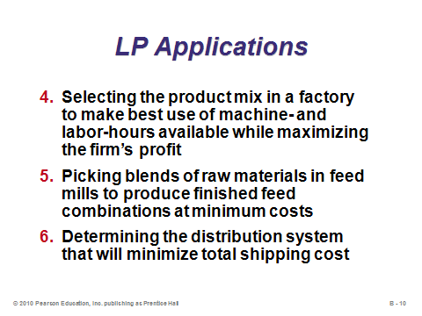

**B-8 B-9 B-10**

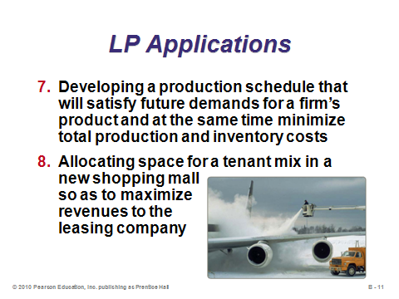

**B-11**

REQUIREMENTS OF A LINEAR PROGRAMMING PROBLEM (B-12 through B-13)

Slides 12-13: These slides present the requirements of a linear programming problem. An equation is *linear* if it is written in the form *A1X1* + *A2X2* + ... + *ANXN* = *C*, where the *Xi* are real, integer, or binary variables, the *Ai* are positive or negative coefficients, and *C* is a constant. In other words, the variables cannot be raised to a higher power, variables cannot be multiplied together, etc. *Nonlinear* programs can be formulated and sometimes solved with the help of computers, but the solutions are not guaranteed to be optimal.

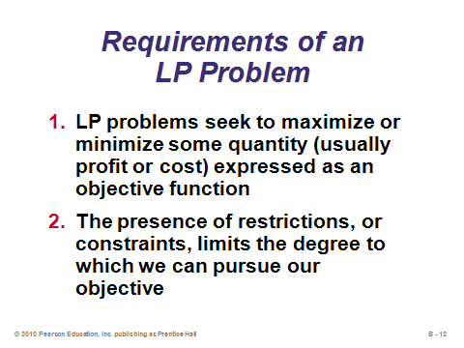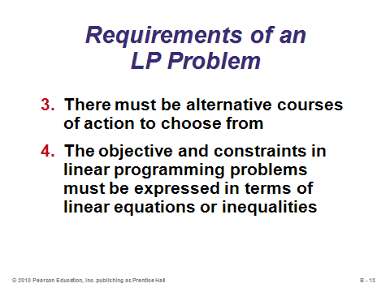

**B-12 B-13**

FORMULATING LINEAR PROGRAMMING PROBLEMS (B-14 through B-17)

Slides 14-17: Here we see an example of the classic and most common *product-mix* problem. The solution determines the number of units of each product to make.

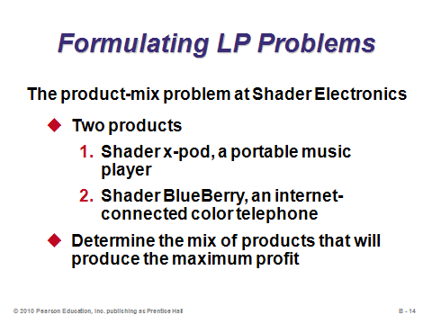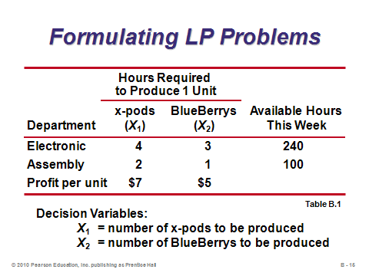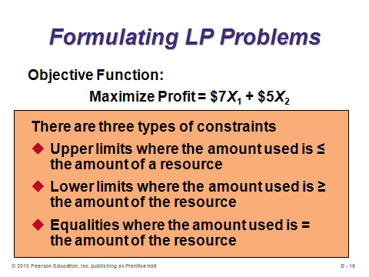

**B-14 B-15 B-16**

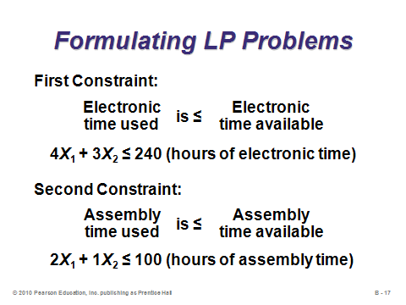

**B-17**

GRAPHICAL SOLUTION TO A LINEAR PROGRAMMING PROBLEM (B-18 through B-27)

Slide 18: Linear programs with two variables can be solved graphically. This is seldom done in practice because computers can solve two-variable problems so easily. Nevertheless, examination of the graphical solution provides insight into the structure of linear programming problems in higher dimensions, and it helps us understand how the computers solve these problems and why the optimal solution must always be at a corner point. Slide 18 presents the steps for the iso-profit line graphical solution method.

Slides 19-23: These slides solve the linear program from Slide 15 via the iso-profit line method.

Slides 24-27: The corner-point graphical solution method recognizes that an optimal solution to any linear program will occur at a corner point, i.e. at an *extreme* point of the feasible region (a point at the boundary of the feasible region where two constraints intersect). Thus, the optimal solution to a maximization problem can be found by plugging the value of each corner point into the objective function and choosing the point that maximized it. Slides 25-27 solve the linear program from Slide 15 via the corner-point method.

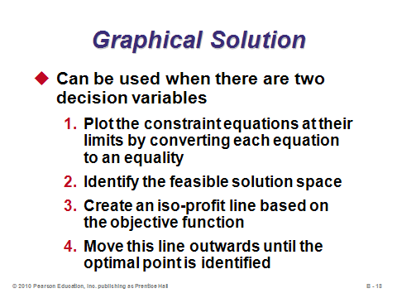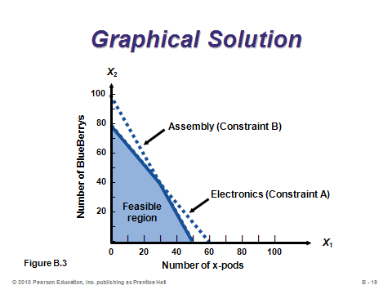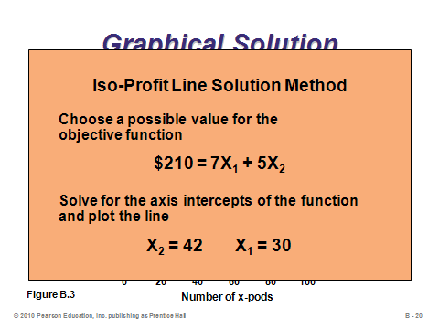

**B-18 B-19 B-20**

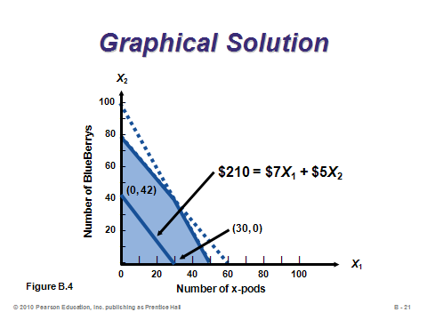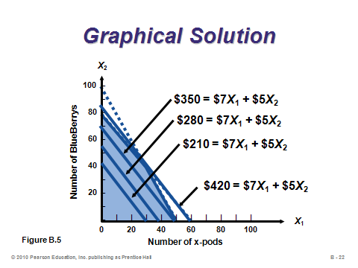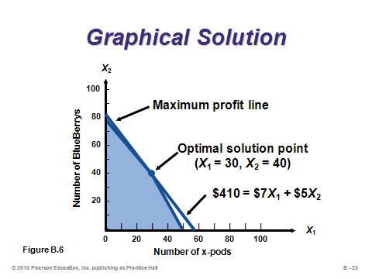

**B-21 B-22 B-23**

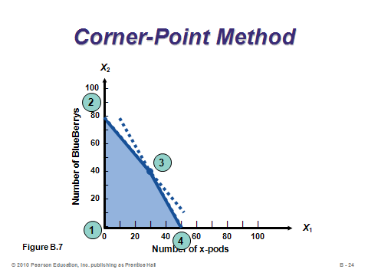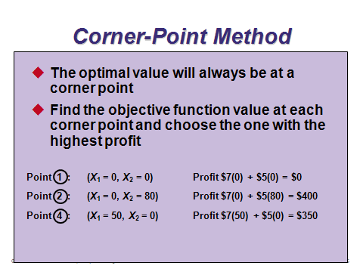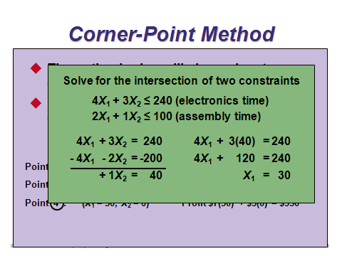

**B-24 B-25 B-26**

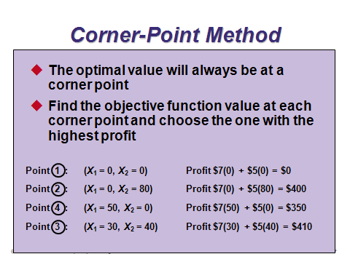

**B-27**

SENSITIVITY ANALYSIS (B-28 through B-34)

Slides 28-34: Sensitivity analysis of linear programs is very useful for answering what-if questions. The user could simply change inputs and re-run the model every time, but a more streamlined and informative method for sensitivity analysis is called the *analytic postoptimality method*. Computer programs produce a sensitivity report like that shown in Slide 29. It provides information about the constraints and objective function values. Slides 30-33 describe the concept of a *shadow price* (or *dual price*) relating to the right-hand side of constraints (which are often expressed as some sort of limit on resources). Slide 34 describes sensitivity analysis for the objective function coefficients. That information shows what kind of coefficient changes would produce a different optimal solution for the decision variables. One caveat: These reports are only valid for one change at a time. The program would need to be re-run to see the effects of changes to two or more parameters.

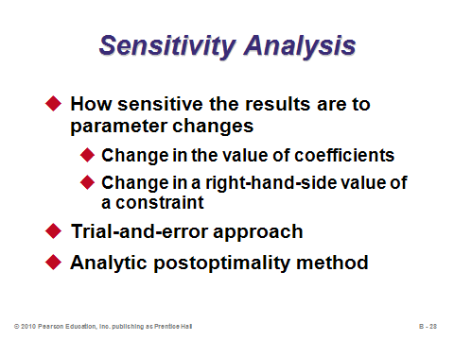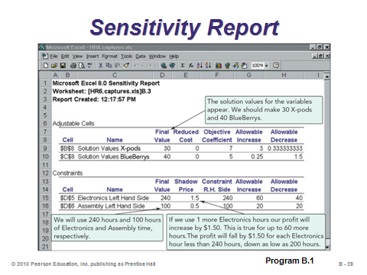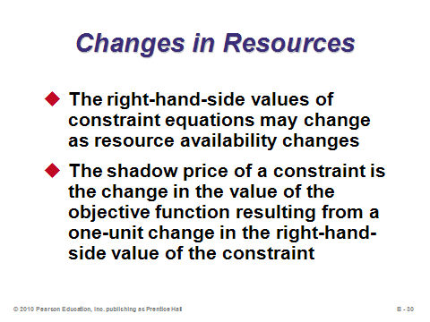

**B-28 B-29 B-30**

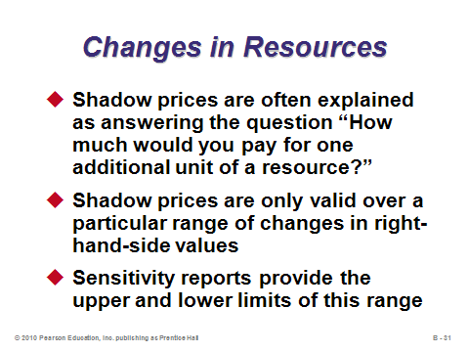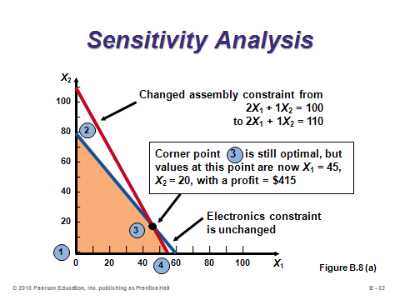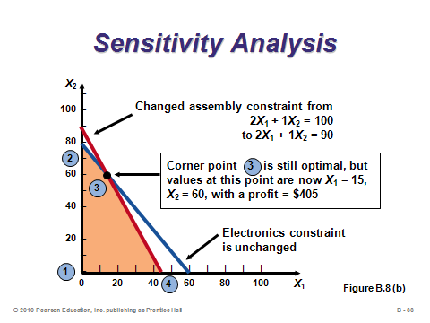

**B-31 B-32 B-33**

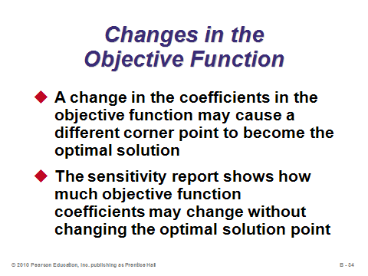

**B-34**

SOLVING MINIMIZATION PROBLEMS (B-35 through B-38)

Slides 35-38: Graphically, minimization problems are solved the same way as maximization problems, except that the objective function (*iso-cost line*) is pushed inwards instead of outwards. Slides 36-38 provide an example.

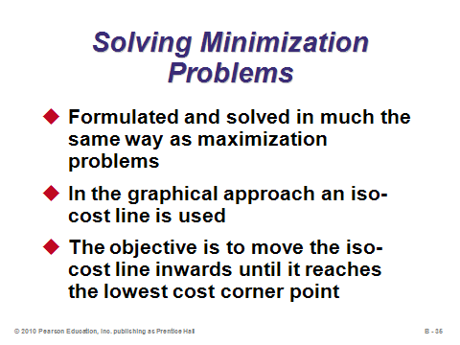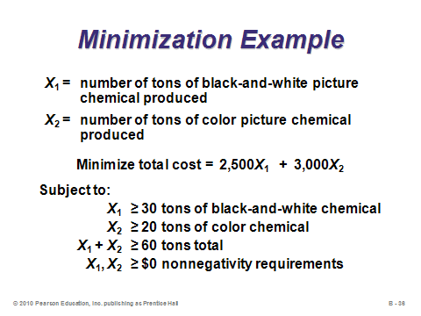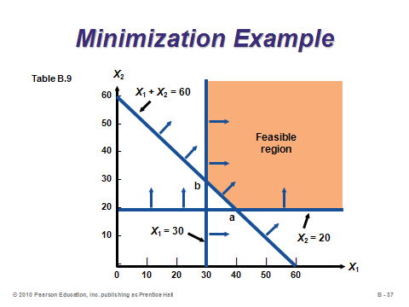

**B-35 B-36 B-37**

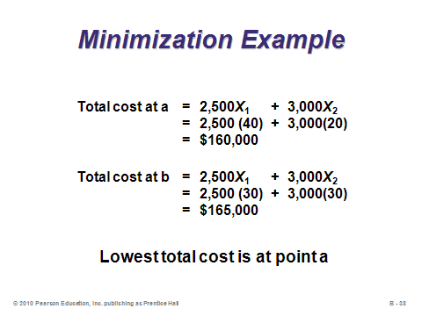

**B-38**

LINEAR PROGRAMMING APPLICATIONS (B-39 through B-46)

Slides 39-46: Three more complex LP applications are presented in these slides. They all have more than two variables, so they cannot be graphed. Slides 39-40 (Example B2) present a production-mix example with four products and four operations, along with minimum production level constraints. Slides 41-42 (Example B3) present a diet problem example where cattle feed must be purchased and mixed, ensuring that the ingredient requirements are satisfied. Slides 43-46 (Example B4) present a labor scheduling example that seeks to assign workers to pre-defined shifts in order to satisfy demand for tellers during each hour of the workday. This is a very useful application that students may find use for in their current or future jobs. Many real-world managers struggle with this decision and potentially waste a lot of labor costs by not generating an optimal schedule.

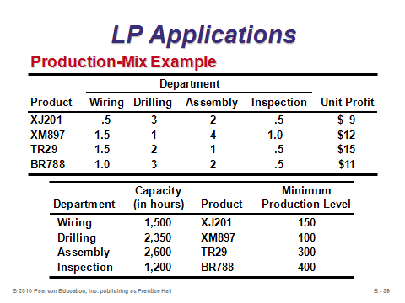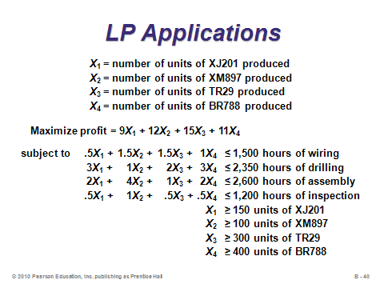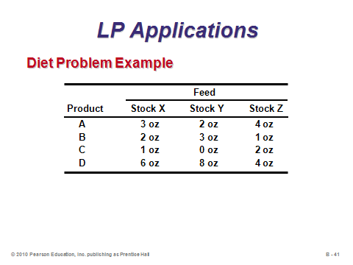

**B-39 B-40 B-41**

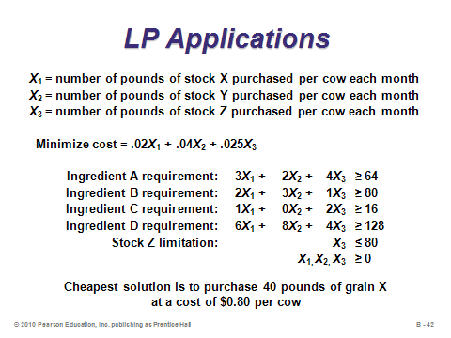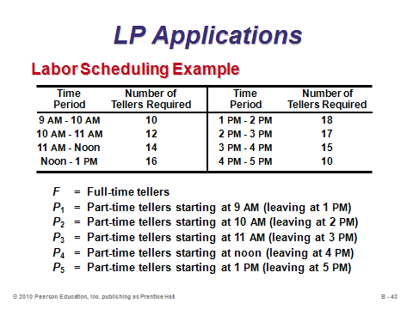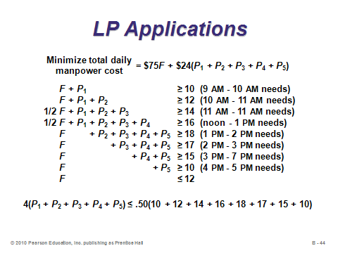

**B-42 B-43 B-44**

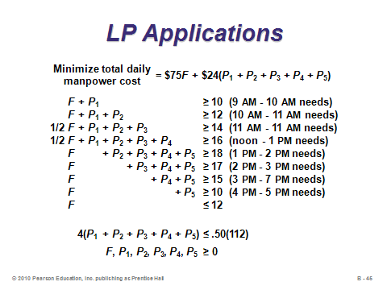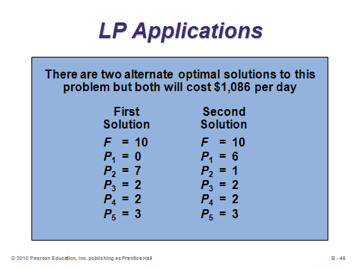

**B-45 B-46**

THE SIMPLEX METHOD OF LP (B-47)

Slide 47: The simplex method revolutionized optimization theory. It can be used to solve problems by hand, but we generally let the computers do the computational work for us. For instructors who want to delve more deeply into linear programming, the Online Tutorial 3 is a full chapter length treatment of the simplex method, with questions, problems, etc.

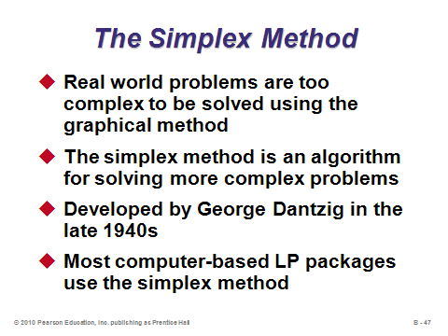

**B-47**

**Additional Assignment Ideas**

1. Visit the Web sites of two linear programming software products and describe the features. Provide several screen captures with your write-up. Here are two possible starting places:

* http://www.ilog.com/products/optimization/
* http://maximal-usa.com

**Additional Case Study**

Internet Case Study (www.pearsonhighered.com/heizer)

* *Chase Manhattan Bank*: This scheduling case involves finding the optimal number of full-time versus part-time employees at a bank.

**Other Supplementary Material**

Learning Game

* Park, J. and Nam, S-H. (2006). Teaching Lot-Size Decisions: A Spreadsheet/Mixed-Integer Programming Approach. *Decision Sciences Journal of Innovative Education*, 4(1), 163-167.
  + Teaching brief describes the use of spreadsheets formulation applied to the MRP lot-sizing decision.

Videos

* *Juicy Problems* from COMAPs “For All Practical Purposes” series (http://www.comap.com/FAP/)
  + This does an excellent job of introducing linear programming.